

**WEB DEVELOPMENT PROJECT**



**Supervised by:**

|  |
| --- |
| **Dr. Mostafa EL Gendy** |
| **Eng. Abdallah Mohamed** |
| **Eng. Amany Saeed** |

**Project Team Members:**

|  |  |
| --- | --- |
| **Omar Wafaey Ahmed** | **Section 3** |
| **Roaa Ayman Mohamed Mohamed** | **Section 2** |
| **Doha Abd Elwahab Mohamed** | **Section 3** |
| **Fatma Ebrahim Abu Elnasr** | **Section 3** |
| **Maher Ahmed Nagib** | **Section 3** |
| **Ziad Adel Abdallah** | **Section 2** |

**Planning Phase:**

* **Project Description:**

This website is focused on on-line appointments or reservation system for clinics.

The main objective is to provide the best clinic services to patients and to reduce waiting time. As a web-based online clinic reservation system, the internet as the communication must need to apply. By using a web site, the reservation processing between customer and clinic administrator will be done. The website administrator can manage a patient record, doctor record, and check the patient condition of this system. Customers can view and select available doctors and can also register by using online. In addition, doctors can search and view patient reservation information.

* **Main Objective:**

The general objective is to design and develop a Medical Clinic System.

(CMS) for HAYAH MEDICAL CLINICS to improve and make the system from manual to computerized that would enable the clinic for faster and more efficient storage, retrieval and updating of the clinic's record.

* **Project Scope:**

The Clinic Management System was primarily developed to improve the clinic's system for storing data or information about the patient and the admin.

The system was focused on moving the manual system into a computerized system that updates and accommodates the process of viewing and storing information about the patient and for the admin that is also responsible for records. The system also deals with searching capability procedure of recorded patient and employee which helps the user for easy retrieval of the records.

* **System Requirements:**
* **Functional Requirements**

**1-Registration:**

-The system must **allow the Patient to register for making an appointment.**

**2-Log in:**

-The system should **allow admins and doctors to** **login to the system using their username and password.**

**3-Making an appointment:**

-The system allows patients to **search for appointments using specific categories.**

-The system shall **allow the patient to view a detailed description of the appointments.**

-The system must allow the customers to **select specific specialization using different search doctors, specializations and fees while making a reservation.**

-The system must **view a list of available appointments.**

**4-Report Generation for patients:**

* **Information of the Patient:**

HAYAH Medical Clinics System generates a report on every patient regarding various information like patient’s name, Phone number, the doctor’s name whom it assigns, and more.

* **Updating information of the Patient:**

HAYAH Medical Clinics System enables doctors to update the information of the patient as described in the mandatory information included.

* **Updating information for doctors and admins:**

-The system **allows the admins to add new admins or doctors accounts.**

* **Non-functional Requirements**

Non-functional requirements, as the name suggests, are requirements that are not directly concerned with the specific services delivered by the system to its users. They may relate to emergent system properties such as reliability, response time, and store occupancy. Alternatively, they may define constraints on the system implementation such as the capabilities of I/O devices or the data representations used in interfaces with other systems. non-functional requirements, such as performance, security, or availability, usually specify or constrain characteristics of the system.

* **Usability:**

The system provides a help and support menu in all interfaces for the user to interact with the system. The user can use the system by reading help and support.

* **Security:**

The system provides username and password to prevent the system from unauthorized access.

The staffs’ password must be

greater than eight characters. The subsystem should provide a high level of security and integrity of the data held by the system, only authorized personnel of the company can gain access to the company’s secured page on the system; and only users with valid password and username can login to view user’s page.

* **Performance:**

The system response time for every instruction conducted by the user must response quickly.

The system should have high performance rate when executing the user’s input and should be able to provide a response within a short time.

* **Availability:**

The system should always be available for access 24 hours. Also, in the occurrence of any major system malfunctioning, the system.

* **Error handling:**

Errors should be considerably minimized and an appropriate error message that guides the user to recover from an error should be provided. Validation of user’s input is highly essential.

* **Ease of use:**

Considering the level of knowledge possessed by the users of this system, a simple but quality user interface should be developed to make it easy to understand and require less training.

**Design Phase:**

1. **USE CASES**

USE CASE (1)

|  |  |  |
| --- | --- | --- |
| **Use Case ID:** | UC-1 | |
| **Use Case Name:** | Registration | |
| **Actors:** | | Patient |
| **Preconditions:** | | 1.Enter username  2.Enter Password  3.Enter Phone number  4.Enter Email |
| **Postconditions:** | | 1.Registration Successfully  2.login |
| **Normal Flow:** | | -After entering our website choose to register if it is the first visit -enter your right information   * username * Password * Phone number * Email |
| **Alternative Flows:** | | If the patient already has an email, it will appear a message that it already exists. |
| **Exceptions:** | | Entering Error Username or password so a message will appear too the  Passenger to re _enter a correct password and username so return to normal flow. |

USE CASE (2)

|  |  |  |
| --- | --- | --- |
| **Use Case ID:** | UC-2 |  |
| **Use Case Name:** | Login |  |
| **Actors:** | | patient, Admin, and doctor |
| **Preconditions:** | | Patient, Admin, and doctor must do registration |
| **Postconditions:** | | 1.Login Successfully  For The patient will enter his account and can make an appointment.  For The admin can manage the whole system.  For The doctor can manage patient prescription. |
| **Normal Flow:** | | 1.Insert Username  2.Insert Password  3.Login |
| **Alternative Flows:** | | None. |
| **Exceptions:** | | Entering Error Username or password so a message will appear to re _enter a correct password and username so return to normal flow. |

USE CASE (3)

|  |  |  |
| --- | --- | --- |
| **Use Case ID:** | UC-3 | |
| **Use Case Name:** | Make an appointment | |
| **Actors:** | | patient |
| **Preconditions:** | | -patient must do registration if he hasn’t account or login if he already logged in to system with his email.  -patient has successfully generated a list appointment. |
| **Postconditions:** | | 1. The patient will enter his account and can check for the appointment |
| **Normal Flow:** | | 1. Selects the " Specialization: 2. Select “doctor”. 3. Select “appointment date” 4. Select “appointment time”   6-click “create new entry”.  Display the message “appointment Successfully Made" |
| **Alternative Flows:** | | None |
| **Exceptions:** | | 1-Does not complete all the necessary fields.  2-Redisplays the input fields from step 2 with the input data and a note stating that certain required data is missing or invalid.  3-Selects the "Cancel" option.  4-Displays the main options screen. |

USE CASE (4)

|  |  |  |
| --- | --- | --- |
| **Use Case ID:** | UC-4 | |
| **Use Case Name:** | Add doctor | |
| **Actors:** | | admin |
| **Preconditions:** | | -admin must login, he already logged in to system with his email.    -An admin page will appear |
| **Postconditions:** | | 1. The Doctor will be added |
| **Normal Flow:** | | 1-Selects the "add doctor" option.  2-Displays a screen with an input field for adding doctor.  3-Enters all fields and clicks the "Add doctor" button.  4-Displays the main admin screen. The message "doctor added Successfully " is also displayed. |
| **Alternative Flows:** | | None |
| **Exceptions:** | | 1-Does not complete all the necessary fields.  2-Return to admin main page. |

USE CASE (5)

|  |  |  |
| --- | --- | --- |
| **Use Case ID:** | UC-5 | |
| **Use Case Name:** | delete doctor | |
| **Actors:** | | admin |
| **Preconditions:** | | -admin must login, he already logged in to system with his email.    -An admin page will appear |
| **Postconditions:** | | 1. The Doctor will be deleted |
| **Normal Flow:** | | 1-Selects the "delete doctor" option.  2-Displays a screen with an (email id) input field for deleting doctors.  3-Enters all fields and clicks the "delete doctor" button.  4-Displays the main admin screen. The message "doctor deleted Successfully " is also displayed. |
| **Alternative Flows:** | | None |
| **Exceptions:** | | 1-Does not complete all the necessary fields.  2-Return to admin main page. |

USE CASE (6)

|  |  |  |
| --- | --- | --- |
| **Use Case ID:** | UC-6 | |
| **Use Case Name:** | Show prescription | |
| **Actors:** | | doctor |
| **Preconditions:** | | -doctor must login, he already logged in to system with his email.    -A doctor page will appear |
| **Postconditions:** | | 1. The Doctor will add prescription for patient |
| **Normal Flow:** | | 1-Selects the "prescription list" option.  2-Displays a screen with diseases and prescription for patients. |
| **Alternative Flows:** | | None |
| **Exceptions:** | | none |

USE CASE (7)

|  |  |  |
| --- | --- | --- |
| **Use Case ID:** | UC-7 | |
| **Use Case Name:** | Message Feedback | |
| **Actors:** | | patient |
| **Preconditions:** | | -patient must login, he already logged in to system with his email and password.  -click contact page |
| **Postconditions:** | | 1. contact page displayed |
| **Normal Flow:** | | 1-In drop us a message area enter input fields.  (Name, email, phone, and message you wanted to say) |
| **Alternative Flows:** | | None |
| **Exceptions:** | | 1-Does not complete all the necessary fields.  2-Return to main page. |

**2-Activity Diagram:**

* ***Activity diagram of Registration use case:***

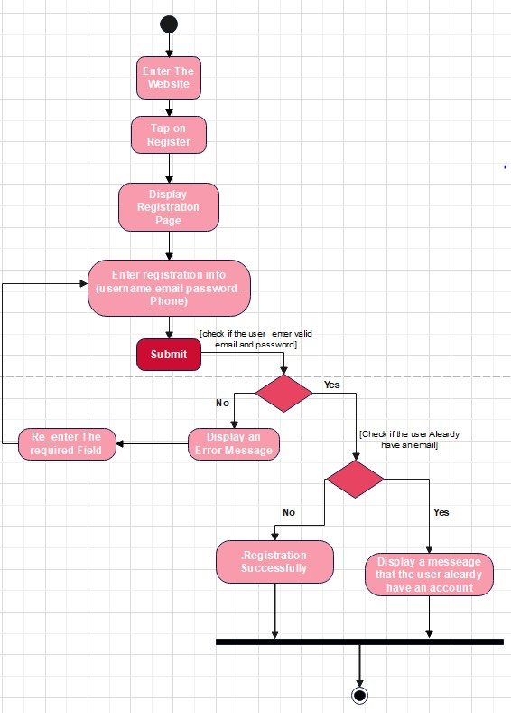

* ***Activity diagram of Login use case:***Diagram, schematic

  Description automatically generated
* ***Activity diagram of Make an appointment use case:***

* ***Activity diagram of Add doctor use case:***

* ***Activity diagram of delete doctor*** ***use case:***

* ***Activity diagram of Show prescription use case:***

* ***Activity diagram of Message Feedback use case:***

***Class diagram:***

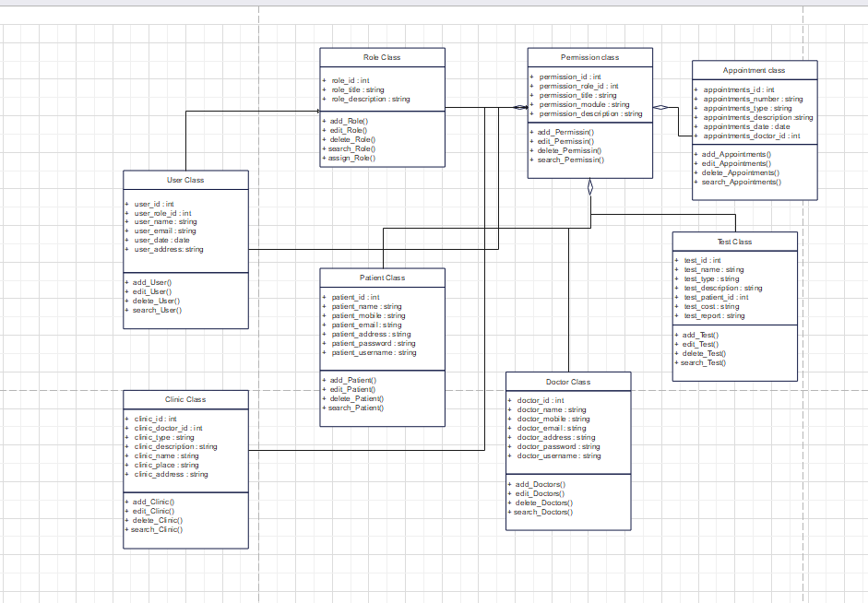

***Sequence diagram:***

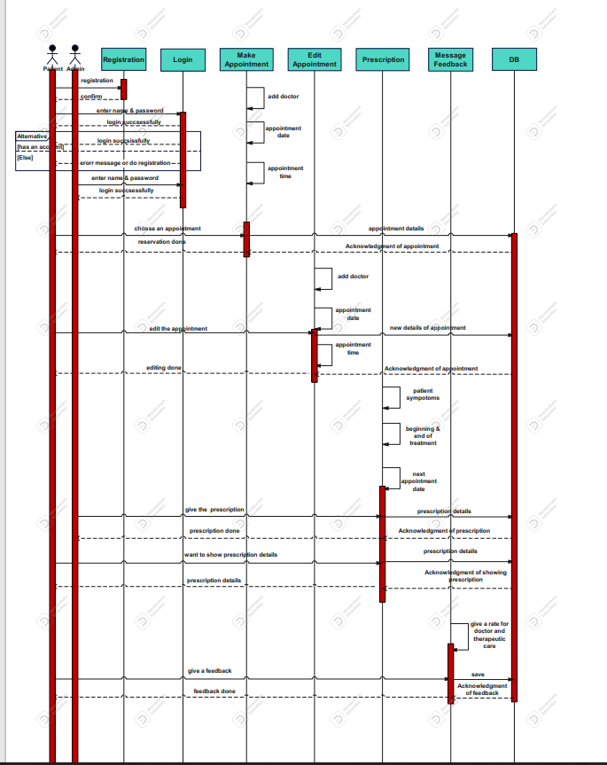

***ERD diagram:***

